**符昕宇 202364810311**

**To access my code more easily, you can find them at my github repository:**

**https://github.com/Fluorine-Brian/Code-for-Digital-Image-Processing**

**Homework1: Implement Figure 9.5 by programming with Python**

**Python Code:**

**import** numpy as np

**import** cv2

**import** matplotlib.pyplot as plt

**import** os

**from** scipy **import** ndimage

MANUAL_INVERT **=** False

**def** perform_erosion(binary_image, size):

    """

    执行形态学腐蚀

    """

    structure **=** np.ones((size, size), dtype**=**bool)

    eroded_mask **=** ndimage.binary_erosion(binary_image, structure**=**structure)

**return** eroded_mask.astype(np.uint8) **\*** 255

**if** __name__ **==** "__main__":

    input_dir **=** "original_image"

    output_dir **=** "output_image"

    os.makedirs(output_dir, exist_ok**=**True)

    image_filename **=** "Fig0905(a)(wirebond-mask).tif"

    image_path **=** os.path.join(input_dir, image_filename)

    raw_image **=** cv2.imread(image_path, cv2.IMREAD_GRAYSCALE)

    binary_image **=** raw_image > 127

**if** MANUAL_INVERT:

        binary_image **=** ~binary_image

    foreground_pixels **=** np.sum(binary_image)

    total_pixels **=** binary_image.size

    ratio **=** foreground_pixels **/** total_pixels

    # 11x11

    image_b **=** perform_erosion(binary_image, 11)

    # 15x15

    image_c **=** perform_erosion(binary_image, 15)

    # 45x45

    image_d **=** perform_erosion(binary_image, 45)

    fig, axes **=** plt.subplots(2, 2, figsize**=**(10, 10))

    fig.suptitle(f'Morphological Erosion (Fig 9.5) - {image_filename}', fontsize**=**16)

    display_original **=** binary_image.astype(np.uint8) **\*** 255

    axes[0, 0].imshow(display_original, cmap**=**'gray', vmin**=**0, vmax**=**255)

    axes[0, 0].set_title('a) Original Image (White=Object)')

    axes[0, 1].imshow(image_b, cmap**=**'gray', vmin**=**0, vmax**=**255)

    axes[0, 1].set_title('b) Erosion with 11x11 SE')

    axes[1, 0].imshow(image_c, cmap**=**'gray', vmin**=**0, vmax**=**255)

    axes[1, 0].set_title('c) Erosion with 15x15 SE')

    axes[1, 1].imshow(image_d, cmap**=**'gray', vmin**=**0, vmax**=**255)

    axes[1, 1].set_title('d) Erosion with 45x45 SE')

**for** ax **in** axes.flat:

        ax.axis('off')

    plt.tight_layout(rect**=**[0, 0.03, 1, 0.95])

    save_path **=** os.path.join(output_dir, f"{os.path.splitext(image_filename)[0]}_final_fix.png")

    plt.savefig(save_path, bbox_inches**=**'tight')

    plt.close()

**Processed Images:**

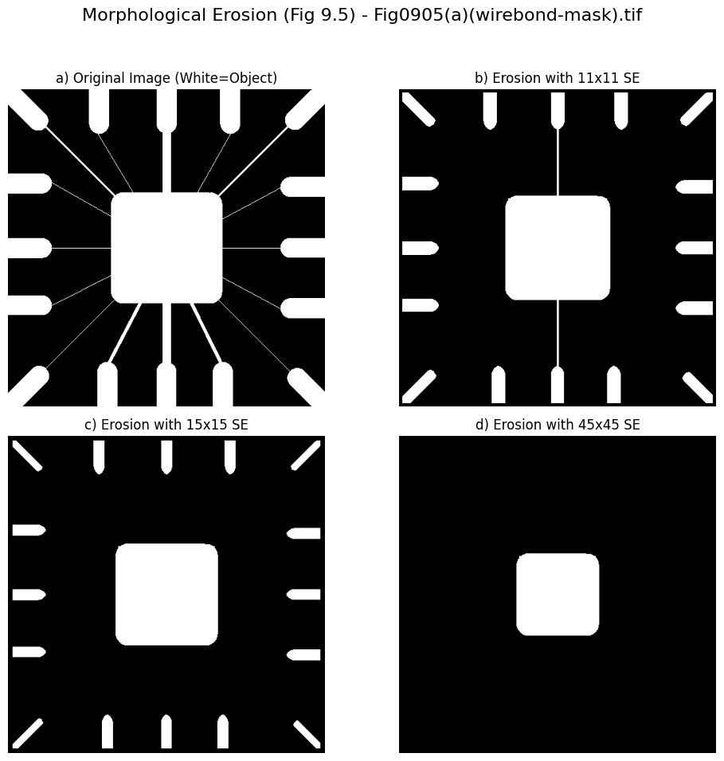

**Homework2: Implement Figure 9.7 by programming with Python**

**Python Code:**

**import** numpy as np

**import** imageio.v2 as imageio

**import** matplotlib.pyplot as plt

**import** os

**from** scipy **import** ndimage

**def** perform_dilation(binary_image, size):

    """

    执行形态学膨胀操作

    """

    structure **=** np.ones((size, size), dtype**=**bool)

    dilated_mask **=** ndimage.binary_dilation(binary_image, structure**=**structure)

**return** dilated_mask.astype(np.uint8) **\*** 255

**if** __name__ **==** "__main__":

    input_dir **=** "original_image"

    output_dir **=** "output_image"

    os.makedirs(output_dir, exist_ok**=**True)

    image_filename **=** "Fig0907(a)(text_gaps_1_and_2_pixels).tif"

    image_path **=** os.path.join(input_dir, image_filename)

    raw_image **=** imageio.imread(image_path)

    binary_image **=** raw_image.astype(bool)

    size_se **=** 3

    image_c **=** perform_dilation(binary_image, size_se)

    fig, axes **=** plt.subplots(1, 2, figsize**=**(12, 6))

    fig.suptitle(f'Morphological Dilation (Fig 9.7) - {image_filename}', fontsize**=**16)

    display_original **=** binary_image.astype(np.uint8) **\*** 255

    axes[0].imshow(display_original, cmap**=**'gray', vmin**=**0, vmax**=**255)

    axes[0].set_title('a) Original Image (Broken Text)')

    axes[1].imshow(image_c, cmap**=**'gray', vmin**=**0, vmax**=**255)

    axes[1].set_title(f'c) Dilation with {size_se}x{size_se} SE (Repaired Text)')

**for** ax **in** axes.flat:

        ax.axis('off')

    plt.tight_layout(rect**=**[0, 0.03, 1, 0.95])

    combined_output_path **=** os.path.join(output_dir, f"{os.path.splitext(image_filename)[0]}_dilation_corrected.png")

    plt.savefig(combined_output_path, bbox_inches**=**'tight')

plt.close()

**Processed Images:**

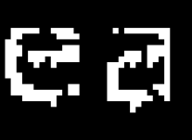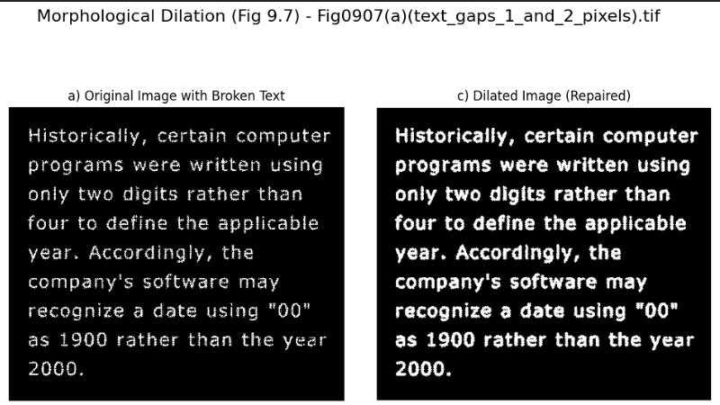

**Homework3: Implement Figure 9.11 by programming with Python**

**Python Code:**

**import** numpy as np

**import** matplotlib.pyplot as plt

**import** os

**from** scipy **import** ndimage

**from** PIL **import** Image

**def** perform_erosion(binary_image, structure):

    """ Performs Morphological Erosion """

**return** ndimage.binary_erosion(binary_image, structure**=**structure)

**def** perform_dilation(binary_image, structure):

    """ Performs Morphological Dilation """

**return** ndimage.binary_dilation(binary_image, structure**=**structure)

**if** __name__ **==** "__main__":

    input_dir **=** "original_image"

    output_dir **=** "output_image"

    os.makedirs(output_dir, exist_ok**=**True)

    image_filename **=** "Fig0911(a)(noisy_fingerprint).tif"

    image_path **=** os.path.join(input_dir, image_filename)

    raw_image_pil **=** Image.open(image_path).convert('L')

    raw_image **=** np.array(raw_image_pil)

    binary_image **=** raw_image > 128

    structure_size **=** 3

    structure **=** np.ones((structure_size, structure_size), dtype**=**bool)

    display_original **=** binary_image.astype(np.uint8) **\*** 255

    image_c_eroded_bool **=** perform_erosion(binary_image, structure)

    image_c **=** image_c_eroded_bool.astype(np.uint8) **\*** 255

    image_d_opened_bool **=** perform_dilation(image_c_eroded_bool, structure)

    image_d **=** image_d_opened_bool.astype(np.uint8) **\*** 255

    image_e_dilated_again_bool **=** perform_dilation(image_d_opened_bool, structure)

    image_e **=** image_e_dilated_again_bool.astype(np.uint8) **\*** 255

    image_f_closed_bool **=** perform_erosion(image_e_dilated_again_bool, structure)

    image_f **=** image_f_closed_bool.astype(np.uint8) **\*** 255

    fig, axes **=** plt.subplots(2, 3, figsize**=**(15, 10))

    fig.suptitle(f'Morphological Filtering (Fig 9.11) - {image_filename}', fontsize**=**16)

    axes[0, 0].imshow(display_original, cmap**=**'gray', vmin**=**0, vmax**=**255)

    axes[0, 0].set_title(r'a) Noisy Image ($A$)')

    axes[0, 1].imshow(image_c, cmap**=**'gray', vmin**=**0, vmax**=**255)

    axes[0, 1].set_title(r'c) Eroded Image ($A \ominus B$)')

    axes[0, 2].imshow(image_d, cmap**=**'gray', vmin**=**0, vmax**=**255)

    axes[0, 2].set_title(r'd) Opening ($A \circ B$)')

    axes[1, 0].imshow(image_e, cmap**=**'gray', vmin**=**0, vmax**=**255)

    axes[1, 0].set_title(r'e) Dilation of the Opening ($(A \circ B) \oplus B$)')

    axes[1, 1].imshow(image_f, cmap**=**'gray', vmin**=**0, vmax**=**255)

    axes[1, 1].set_title(r'f) Closing of the Opening ($(A \circ B) \bullet B$)')

    axes[1, 2].axis('off')

**for** ax **in** axes.flat:

        ax.axis('off')

    plt.tight_layout(rect**=**[0, 0.03, 1, 0.95])

    combined_output_path **=** os.path.join(output_dir, f"{os.path.splitext(image_filename)[0]}_morph_filter.png")

    plt.savefig(combined_output_path, bbox_inches**=**'tight')

plt.close()

**Processed Images:**

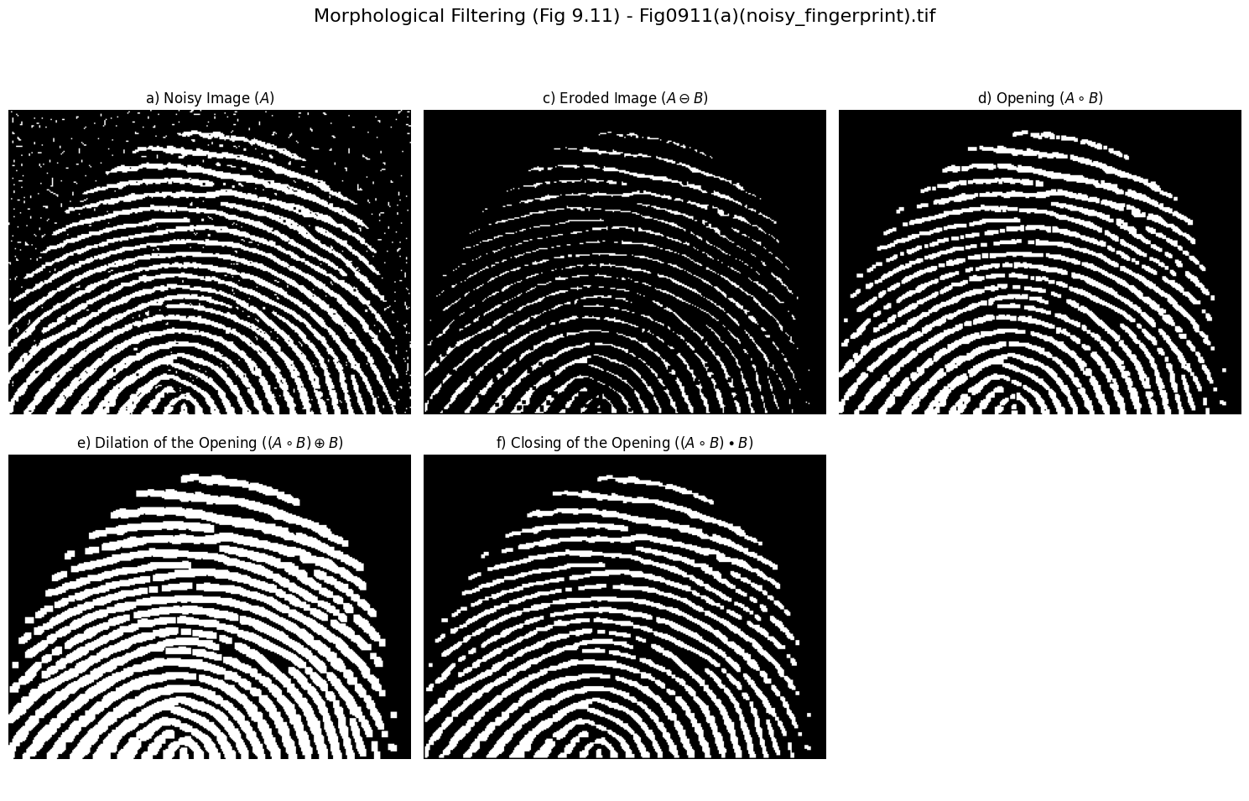

**Homework4: Implement Figure 9.16 by programming with Python**

**Python Code:**

**import** numpy as np

**import** matplotlib.pyplot as plt

**import** os

**from** scipy **import** ndimage

**from** PIL **import** Image

MANUAL_INVERT **=** False

**def** extract_boundary(binary_image, structure):

    # Formula: Beta(A) = A - (A eroded by B)

    eroded **=** ndimage.binary_erosion(binary_image, structure**=**structure)

**return** binary_image ^ eroded

**if** __name__ **==** "__main__":

    input_dir **=** "original_image"

    output_dir **=** "output_image"

    os.makedirs(output_dir, exist_ok**=**True)

    image_filename **=** "Fig0914(a)(licoln from penny).tif"

    image_path **=** os.path.join(input_dir, image_filename)

    raw_image_pil **=** Image.open(image_path).convert('L')

    raw_image **=** np.array(raw_image_pil)

    binary_image **=** raw_image > 128

**if** MANUAL_INVERT:

        binary_image **=** ~binary_image

    structure **=** np.ones((3, 3), dtype**=**bool)

    boundary_image **=** extract_boundary(binary_image, structure)

    fig, axes **=** plt.subplots(1, 2, figsize**=**(10, 5))

    fig.suptitle(f'Boundary Extraction (Fig 9.16) - {image_filename}', fontsize**=**14)

    axes[0].imshow(binary_image.astype(np.uint8) **\*** 255, cmap**=**'gray')

    axes[0].set_title('a) Original Image')

    axes[0].axis('off')

    axes[1].imshow(boundary_image.astype(np.uint8) **\*** 255, cmap**=**'gray')

    axes[1].set_title('b) Boundary Extraction')

    axes[1].axis('off')

    plt.tight_layout()

    save_path **=** os.path.join(output_dir, f"{os.path.splitext(image_filename)[0]}_boundary.png")

    plt.savefig(save_path, bbox_inches**=**'tight')

plt.close()

**Processed Images:**

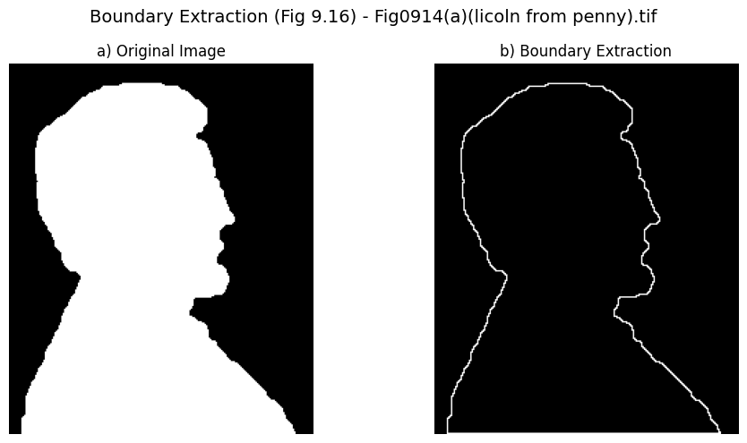

**Homework5: Implement Figure 9.18 by programming with Python**

**Python Code:**

**import** numpy as np

**import** matplotlib.pyplot as plt

**import** os

**from** scipy **import** ndimage

**from** PIL **import** Image

MANUAL_INVERT **=** False

**def** fill_all_holes_robust(binary_image):

    background_mask **=** ~binary_image

    labels, num_features **=** ndimage.label(background_mask)

**if** num_features **==** 0:

**return** binary_image

    sizes **=** np.bincount(labels.ravel())

    main_background_label **=** np.argmax(sizes[1:]) **+** 1

    holes_mask **=** (labels !**=** 0) & (labels !**=** main_background_label)

**return** binary_image | holes_mask

**if** __name__ **==** "__main__":

    input_dir **=** "original_image"

    output_dir **=** "output_image"

    os.makedirs(output_dir, exist_ok**=**True)

    image_filename **=** "Fig0916(a)(region-filling-reflections).tif"

    image_path **=** os.path.join(input_dir, image_filename)

    raw_image_pil **=** Image.open(image_path).convert('L')

    raw_image **=** np.array(raw_image_pil)

    binary_image **=** raw_image > 128

**if** MANUAL_INVERT:

        binary_image **=** ~binary_image

    filled_image **=** fill_all_holes_robust(binary_image)

    fig, axes **=** plt.subplots(1, 2, figsize**=**(10, 5))

    fig.suptitle(f'Morphological Hole Filling (Fig 9.18) - {image_filename}', fontsize**=**14)

    axes[0].imshow(binary_image.astype(np.uint8) **\*** 255, cmap**=**'gray', vmin**=**0, vmax**=**255)

    axes[0].set_title('a) Original Image')

    axes[0].axis('off')

    axes[1].imshow(filled_image.astype(np.uint8) **\*** 255, cmap**=**'gray', vmin**=**0, vmax**=**255)

    axes[1].set_title('b) Hole Filling Result')

    axes[1].axis('off')

    plt.tight_layout()

    save_path **=** os.path.join(output_dir, f"{os.path.splitext(image_filename)[0]}_hole_filling_final.png")

    plt.savefig(save_path, bbox_inches**=**'tight')

    plt.close()

**Processed Images:**

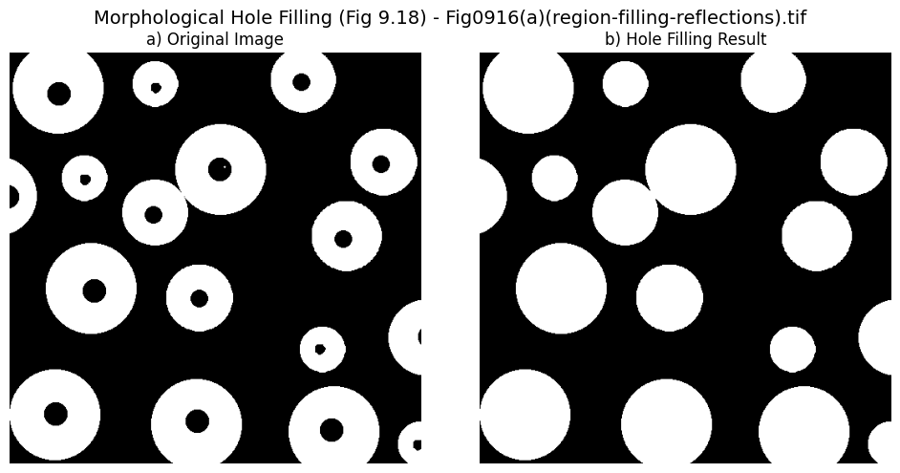

**Homework6: Implement Figure 9.20 by programming with Python**

**Python Code:**

**import** numpy as np

**import** matplotlib.pyplot as plt

**import** os

**from** PIL **import** Image

**from** scipy **import** ndimage

**def** manual_threshold(img_arr, threshold**=**205):

    binary **=** np.zeros_like(img_arr)

    binary[img_arr > threshold] **=** 255

**return** binary

**def** manual_erosion(binary_img, kernel_size**=**5):

    img_bool **=** (binary_img **/** 255).astype(float)

    kernel **=** np.ones((kernel_size, kernel_size), dtype**=**float)

    kernel_area **=** kernel_size **\*** kernel_size

    neighbor_sum **=** ndimage.convolve(img_bool, kernel, mode**=**'constant', cval**=**0.0)

    eroded_bool **=** neighbor_sum > (kernel_area **-** 0.5)

**return** eroded_bool.astype(np.uint8) **\*** 255

**if** __name__ **==** "__main__":

    input_dir **=** "original_image"

    output_dir **=** "output_image"

    os.makedirs(output_dir, exist_ok**=**True)

    image_filename **=** "Fig0918(a)(Chickenfilet with bones).tif"

    image_path **=** os.path.join(input_dir, image_filename)

    pil_img **=** Image.open(image_path).convert('L')

    img **=** np.array(pil_img)

    binary **=** manual_threshold(img, threshold**=**205)

    eroded **=** manual_erosion(binary, kernel_size**=**5)

    display_b **=** 255 **-** binary

    display_c **=** eroded

    fig, axes **=** plt.subplots(3, 1, figsize**=**(6, 12))

    fig.suptitle(f'Connected Components Extraction (Fig 9.20)', fontsize**=**14)

    axes[0].imshow(img, cmap**=**'gray')

    axes[0].set_title('a) Original Image')

    axes[0].axis('off')

    axes[1].imshow(display_b, cmap**=**'gray')

    axes[1].set_title('b) Thresholded (Negative)')

    axes[1].axis('off')

    axes[2].imshow(display_c, cmap**=**'gray')

    axes[2].set_title('c) Eroded (Positive)')

    axes[2].axis('off')

    plt.tight_layout()

    save_path **=** os.path.join(output_dir, "Fig0920_bone_analysis_compact.png")

    plt.savefig(save_path, bbox_inches**=**'tight')

    plt.close()

**Processed Images：**

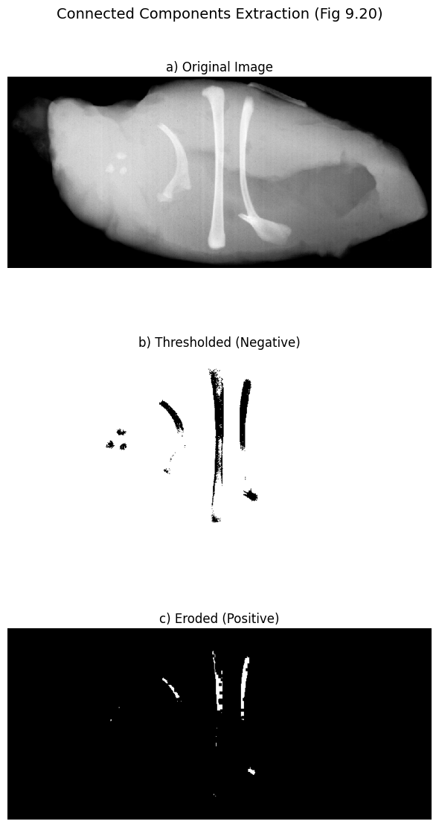

**Homework7: Implement Figure 10.5 by programming with Python**

**Python Code:**

**import** numpy as np

**import** matplotlib.pyplot as plt

**import** os

**from** scipy **import** ndimage

**from** PIL **import** Image

**def** process_laplacian_line_detection(image_path, output_dir):

    pil_img **=** Image.open(image_path).convert('L')

    img **=** np.array(pil_img)

**if** np.mean(img) > 128:

        img **=** 255 **-** img

    img_float **=** img.astype(float)

    kernel **=** np.array([[1, 1, 1],

                       [1, **-**8, 1],

                       [1, 1, 1]], dtype**=**float)

    laplacian **=** ndimage.convolve(img_float, kernel)

    img_b **=** np.clip(laplacian **+** 128, 0, 255)

    img_c **=** np.abs(laplacian)

    img_d **=** np.clip(laplacian, 0, None)

    zoom_slice **=** (slice(125, 175), slice(220, 270))

    img_b_zoom **=** img_b[zoom_slice]

    fig **=** plt.figure(figsize**=**(15, 10))

    ax1 **=** plt.subplot(2, 3, 1)

    ax1.imshow(img, cmap**=**'gray')

    ax1.set_title('a) Original Image')

    ax1.axis('off')

    ax2 **=** plt.subplot(2, 3, 2)

    ax2.imshow(img_b, cmap**=**'gray')

    ax2.set_title('b) Laplacian Image')

    ax2.axis('off')

    ax3 **=** plt.subplot(2, 3, 3)

    ax3.imshow(img_b_zoom, cmap**=**'gray', interpolation**=**'nearest')

    ax3.set_title('b) Zoomed Detail')

    ax3.axis('off')

**for** spine **in** ax3.spines.values():

        spine.set_edgecolor('red')

        spine.set_linewidth(2)

    ax4 **=** plt.subplot(2, 3, 4)

    ax4.imshow(img_c, cmap**=**'gray')

    ax4.set_title('c) Absolute Value')

    ax4.axis('off')

    ax5 **=** plt.subplot(2, 3, 5)

    ax5.imshow(img_d, cmap**=**'gray')

    ax5.set_title('d) Positive Values')

    ax5.axis('off')

    plt.tight_layout()

    save_path **=** os.path.join(output_dir, "Fig1005_line_detection.png")

    plt.savefig(save_path, bbox_inches**=**'tight')

    plt.close()

**if** __name__ **==** "__main__":

    input_dir **=** "original_image"

    output_dir **=** "output_image"

    os.makedirs(output_dir, exist_ok**=**True)

    filename **=** "Fig0905(a)(wirebond-mask).tif"

    path **=** os.path.join(input_dir, filename)

    process_laplacian_line_detection(path, output_dir)

**Processed Images：**

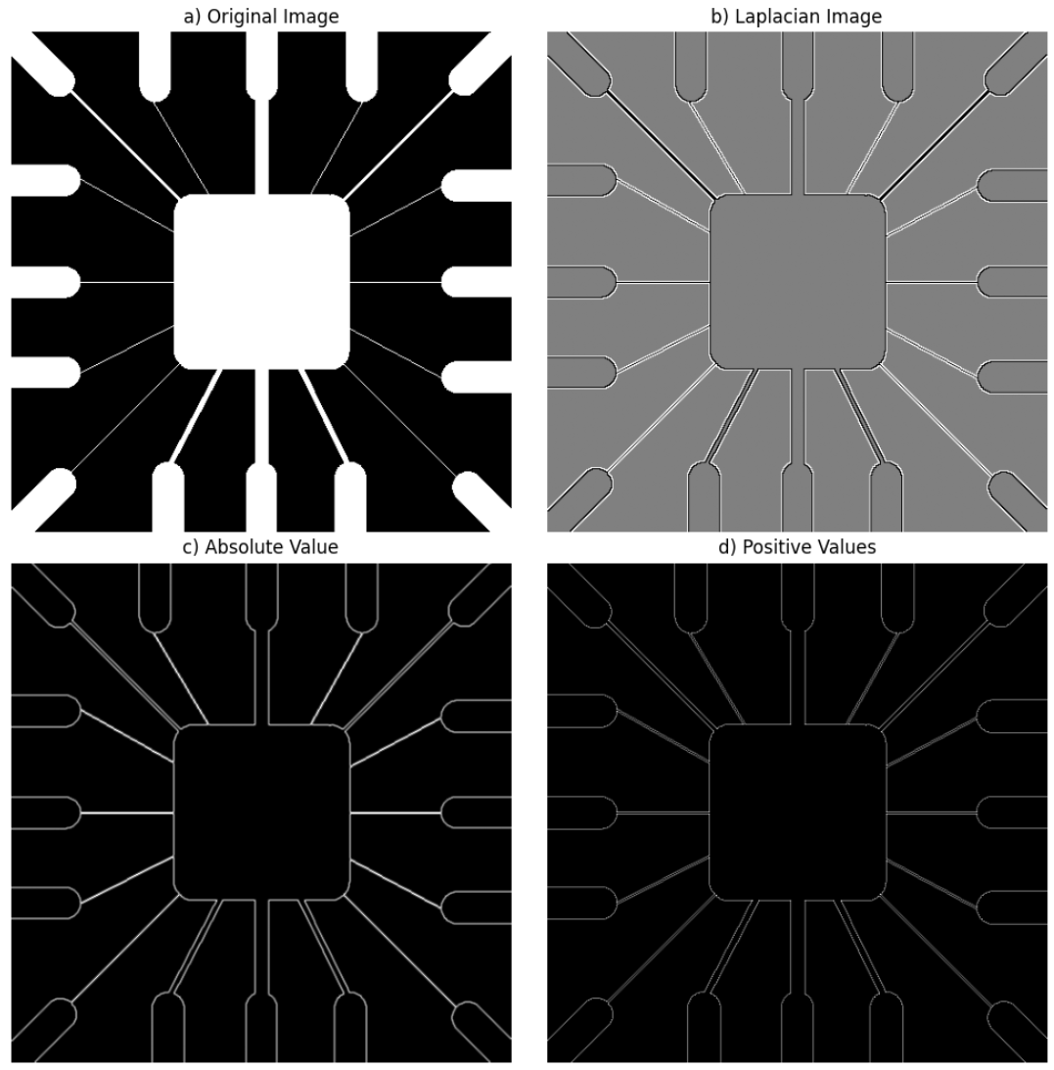

**Homework8: Implement Figure 10.7 by programming with Python**

**Python Code:**

**import** numpy as np

**import** matplotlib.pyplot as plt

**import** os

**from** scipy **import** ndimage

**from** PIL **import** Image

**def** apply_45_degree_kernel(img_arr):

    img_float **=** img_arr.astype(float)

    kernel **=** np.array([[2, **-**1, **-**1],

                       [**-**1, 2, **-**1],

                       [**-**1, **-**1, 2]], dtype**=**float)

    response **=** ndimage.convolve(img_float, kernel)

**return** response

**def** process_and_visualize_six_figures(image_path, output_dir):

    pil_img **=** Image.open(image_path).convert('L')

    img **=** np.array(pil_img)

    raw_response **=** apply_45_degree_kernel(img)

    max_abs **=** np.max(np.abs(raw_response))

**if** max_abs **==** 0: max_abs **=** 1

    display_b **=** ((raw_response **/** max_abs) **\*** 127.5 **+** 127.5).astype(np.uint8)

    slice_c **=** (slice(10, 110), slice(10, 110))

    img_c **=** display_b[slice_c]

    slice_d **=** (slice(370, 480), slice(370, 480))

    img_d **=** display_b[slice_d]

    response_e **=** raw_response.copy()

    response_e[response_e < 0] **=** 0

    display_e **=** np.clip(response_e, 0, 255).astype(np.uint8)

    max_val **=** np.max(response_e)

**if** max_val > 0:

        T **=** max_val

        mask_f **=** response_e >**=** T

**else**:

        mask_f **=** np.zeros_like(response_e, dtype**=**bool)

    img_f_binary **=** np.zeros_like(img)

    img_f_binary[mask_f] **=** 255

    structure **=** np.ones((5, 5), dtype**=**bool)

    img_f_dilated **=** ndimage.binary_dilation(img_f_binary > 0, structure**=**structure)

    img_f **=** img_f_dilated.astype(np.uint8) **\*** 255

    fig, axes **=** plt.subplots(2, 3, figsize**=**(15, 10))

    axes[0, 0].imshow(img, cmap**=**'gray')

    axes[0, 0].set_title('(a) Original Image')

    axes[0, 0].axis('off')

    axes[0, 1].imshow(display_b, cmap**=**'gray')

    axes[0, 1].set_title('(b) +45 Line Response')

    axes[0, 1].axis('off')

    axes[0, 2].imshow(img_c, cmap**=**'gray')

    axes[0, 2].set_title('(c) Zoomed Top-Left')

    axes[0, 2].axis('off')

**for** spine **in** axes[0, 2].spines.values():

        spine.set_edgecolor('white')

    axes[1, 0].imshow(img_d, cmap**=**'gray')

    axes[1, 0].set_title('(d) Zoomed Bottom-Right')

    axes[1, 0].axis('off')

    axes[1, 1].imshow(display_e, cmap**=**'gray')

    axes[1, 1].set_title('(e) Positive Response')

    axes[1, 1].axis('off')

    axes[1, 2].imshow(img_f, cmap**=**'gray')

    axes[1, 2].set_title('(f) Strongest Points (>T)')

    axes[1, 2].axis('off')

    plt.tight_layout()

    save_path **=** os.path.join(output_dir, "Fig1007_full_process.png")

    plt.savefig(save_path, bbox_inches**=**'tight')

    plt.close()

**if** __name__ **==** "__main__":

    input_dir **=** "original_image"

    output_dir **=** "output_image"

    os.makedirs(output_dir, exist_ok**=**True)

    filename **=** "Fig1007(a)(wirebond_mask).tif"

    path **=** os.path.join(input_dir, filename)

process_and_visualize_six_figures(path, output_dir)

**Processed Images：**

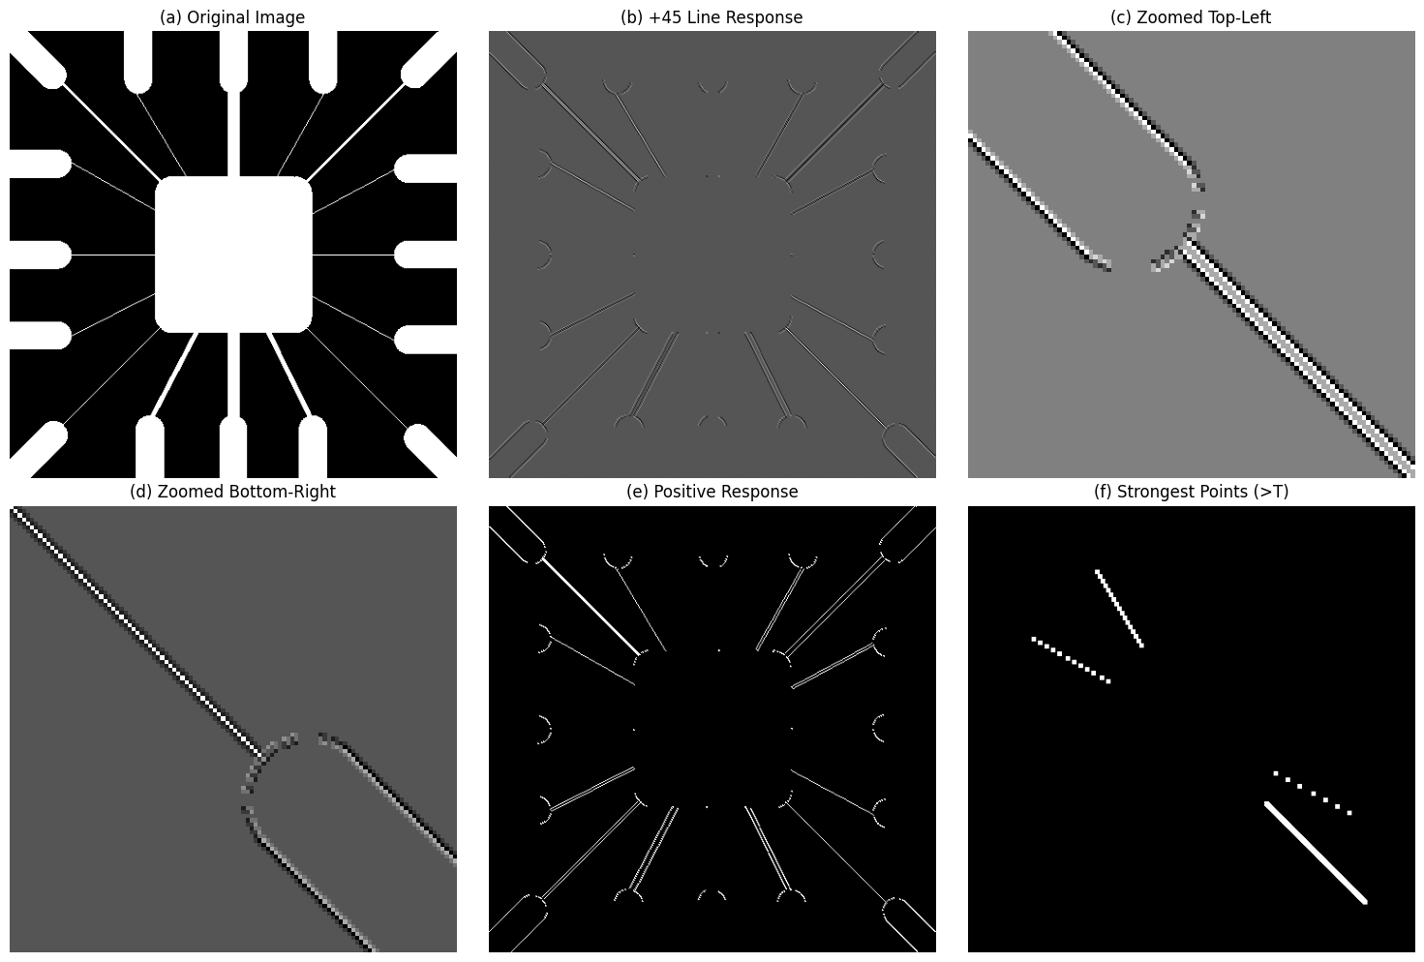

**Homework9: Implement Figure 10.16 by programming with Python**

**Python Code:**

**import** numpy as np

**import** matplotlib.pyplot as plt

**import** os

**from** scipy **import** ndimage

**from** PIL **import** Image

**def** compute_sobel_gradients(img_arr):

    img_float **=** img_arr.astype(float)

    kx **=** np.array([[**-**1, **-**2, **-**1],

                   [0, 0, 0],

                   [1, 2, 1]], dtype**=**float)

    ky **=** np.array([[**-**1, 0, 1],

                   [**-**2, 0, 2],

                   [**-**1, 0, 1]], dtype**=**float)

    gx **=** ndimage.convolve(img_float, kx)

    gy **=** ndimage.convolve(img_float, ky)

**return** np.abs(gx), np.abs(gy)

**def** process_sobel_edge_detection(image_path, output_dir):

    pil_img **=** Image.open(image_path).convert('L')

    img **=** np.array(pil_img)

    abs_gx, abs_gy **=** compute_sobel_gradients(img)

    magnitude **=** abs_gx **+** abs_gy

    display_gx **=** np.clip(abs_gx, 0, 255).astype(np.uint8)

    display_gy **=** np.clip(abs_gy, 0, 255).astype(np.uint8)

    display_mag **=** np.clip(magnitude, 0, 255).astype(np.uint8)

    fig, axes **=** plt.subplots(2, 2, figsize**=**(10, 10))

    axes[0, 0].imshow(img, cmap**=**'gray')

    axes[0, 0].set_title('(a) Original Image')

    axes[0, 0].axis('off')

    axes[0, 1].imshow(display_gx, cmap**=**'gray')

    axes[0, 1].set_title('(b) |gx| component (Vertical Edges)')

    axes[0, 1].axis('off')

    axes[1, 0].imshow(display_gy, cmap**=**'gray')

    axes[1, 0].set_title('(c) |gy| component (Horizontal Edges)')

    axes[1, 0].axis('off')

    axes[1, 1].imshow(display_mag, cmap**=**'gray')

    axes[1, 1].set_title('(d) Gradient image |gx| + |gy|')

    axes[1, 1].axis('off')

    plt.tight_layout()

    save_path **=** os.path.join(output_dir, "Fig1016_sobel_gradients.png")

    plt.savefig(save_path, bbox_inches**=**'tight')

    plt.close()

**if** __name__ **==** "__main__":

    input_dir **=** "original_image"

    output_dir **=** "output_image"

    os.makedirs(output_dir, exist_ok**=**True)

    filename **=** "Fig1016(a)(building_original).tif"

    path **=** os.path.join(input_dir, filename)

    process_sobel_edge_detection(path, output_dir)

**Processed Images：**

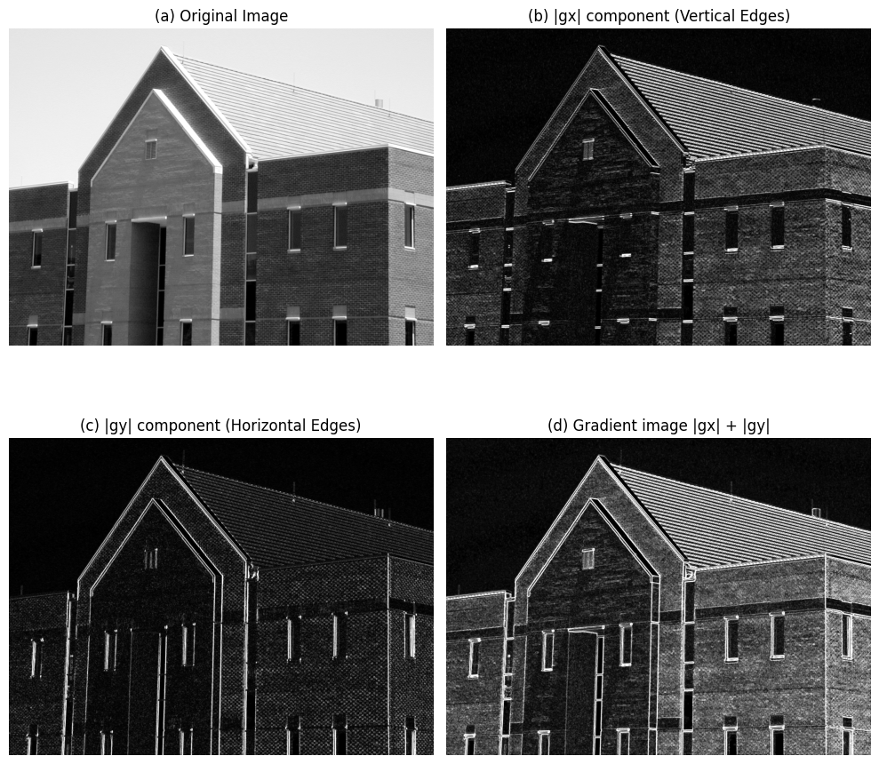

**Homework10: Implement Figure 10.18 by programming with Python**

**Python Code:**

**import** numpy as np

**import** matplotlib.pyplot as plt

**import** os

**from** scipy **import** ndimage

**from** PIL **import** Image

**def** apply_average_filter(img_arr, kernel_size**=**5):

    img_float **=** img_arr.astype(float)

    smoothed **=** ndimage.uniform_filter(img_float, size**=**kernel_size)

**return** smoothed

**def** compute_sobel_gradients(img_arr):

    img_float **=** img_arr.astype(float) **/** 255.0

    kx **=** np.array([[**-**1, **-**2, **-**1],

                   [0, 0, 0],

                   [1, 2, 1]], dtype**=**float)

    ky **=** np.array([[**-**1, 0, 1],

                   [**-**2, 0, 2],

                   [**-**1, 0, 1]], dtype**=**float)

    gx **=** ndimage.convolve(img_float, kx)

    gy **=** ndimage.convolve(img_float, ky)

**return** np.abs(gx), np.abs(gy)

**def** normalize_for_display(img_data):

    min_val **=** np.min(img_data)

    max_val **=** np.max(img_data)

**if** max_val **-** min_val **==** 0:

**return** np.zeros_like(img_data, dtype**=**np.uint8)

    norm_img **=** (img_data **-** min_val) **/** (max_val **-** min_val) **\*** 255

**return** norm_img.astype(np.uint8)

**def** process_smoothed_sobel(image_path, output_dir):

    pil_img **=** Image.open(image_path).convert('L')

    img **=** np.array(pil_img)

    img_smoothed **=** apply_average_filter(img, kernel_size**=**5)

    abs_gx, abs_gy **=** compute_sobel_gradients(img_smoothed)

    magnitude **=** abs_gx **+** abs_gy

    display_gx **=** normalize_for_display(abs_gx)

    display_gy **=** normalize_for_display(abs_gy)

    display_mag **=** normalize_for_display(magnitude)

    fig, axes **=** plt.subplots(2, 2, figsize**=**(10, 12))

    axes[0, 0].imshow(img_smoothed, cmap**=**'gray')

    axes[0, 0].set_title('(a) Smoothed Image (5x5 Avg)')

    axes[0, 0].axis('off')

    axes[0, 1].imshow(display_gx, cmap**=**'gray')

    axes[0, 1].set_title('(b) |gx| (Vertical)')

    axes[0, 1].axis('off')

    axes[1, 0].imshow(display_gy, cmap**=**'gray')

    axes[1, 0].set_title('(c) |gy| (Horizontal)')

    axes[1, 0].axis('off')

    axes[1, 1].imshow(display_mag, cmap**=**'gray')

    axes[1, 1].set_title('(d) Gradient |gx| + |gy|')

    axes[1, 1].axis('off')

    plt.tight_layout()

    save_path **=** os.path.join(output_dir, "Fig1018_smoothed_sobel.png")

    plt.savefig(save_path, bbox_inches**=**'tight')

    plt.close()

**if** __name__ **==** "__main__":

    input_dir **=** "original_image"

    output_dir **=** "output_image"

    os.makedirs(output_dir, exist_ok**=**True)

    filename **=** "Fig1016(a)(building_original).tif"

    path **=** os.path.join(input_dir, filename)

    process_smoothed_sobel(path, output_dir)

**Processed Images：**

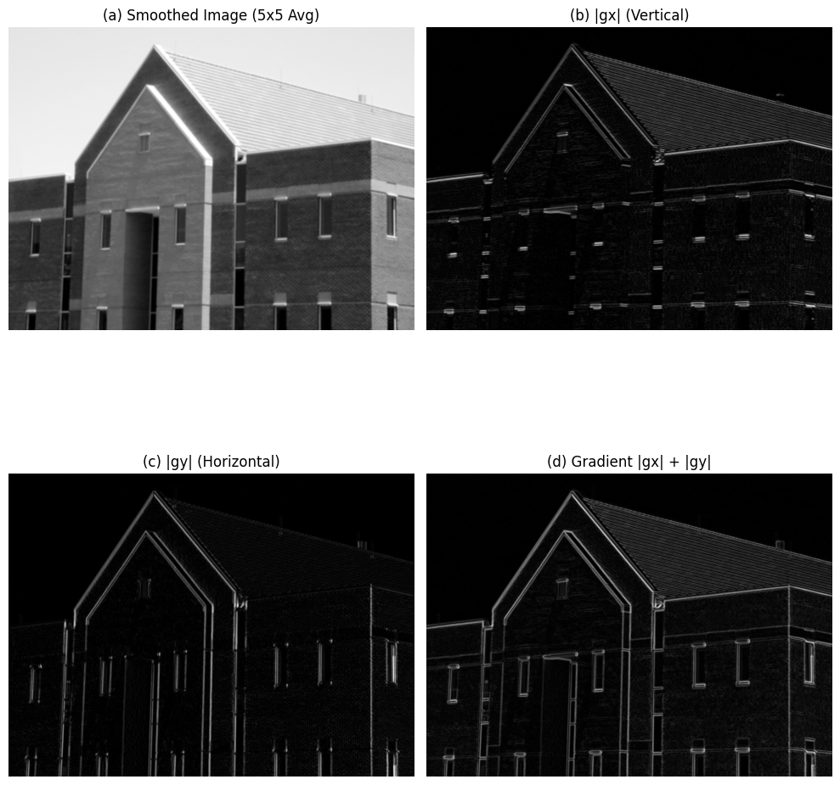

**Homework11: Implement Figure 10.19 by programming with Python**

**Python Code:**

**import** numpy as np

**import** matplotlib.pyplot as plt

**import** os

**from** scipy **import** ndimage

**from** PIL **import** Image

**def** compute_kirsch_responses(img_arr):

    img_float **=** img_arr.astype(float) **/** 255.0

    k_nw **=** np.array([[**-**3, 5, 5],

                     [**-**3, 0, 5],

                     [**-**3, **-**3, **-**3]], dtype**=**float)

    k_sw **=** np.array([[5, 5, **-**3],

                     [5, 0, **-**3],

                     [**-**3, **-**3, **-**3]], dtype**=**float)

    resp_nw **=** ndimage.convolve(img_float, k_nw)

    resp_sw **=** ndimage.convolve(img_float, k_sw)

**return** np.abs(resp_nw), np.abs(resp_sw)

**def** normalize_for_display(img_data):

    min_val **=** np.min(img_data)

    max_val **=** np.max(img_data)

**if** max_val **-** min_val **==** 0:

**return** np.zeros_like(img_data, dtype**=**np.uint8)

    norm_img **=** (img_data **-** min_val) **/** (max_val **-** min_val) **\*** 255

**return** norm_img.astype(np.uint8)

**def** process_diagonal_edge_detection(image_path, output_dir):

    pil_img **=** Image.open(image_path).convert('L')

    img **=** np.array(pil_img)

    img_smoothed **=** img

    abs_nw, abs_sw **=** compute_kirsch_responses(img_smoothed)

    display_nw **=** normalize_for_display(abs_nw)

    display_sw **=** normalize_for_display(abs_sw)

    fig, axes **=** plt.subplots(1, 2, figsize**=**(12, 6))

    fig.suptitle(f'Diagonal Edge Detection (Fig 10.19)', fontsize**=**14)

    axes[0].imshow(display_nw, cmap**=**'gray')

    axes[0].set_title('(a) NW Kernel (45 degree)')

    axes[0].axis('off')

    axes[1].imshow(display_sw, cmap**=**'gray')

    axes[1].set_title('(b) SW Kernel (-45 degree)')

    axes[1].axis('off')

    plt.tight_layout()

    save_path **=** os.path.join(output_dir, "Fig1019_diagonal_edges.png")

    plt.savefig(save_path, bbox_inches**=**'tight')

    plt.close()

**if** __name__ **==** "__main__":

    input_dir **=** "original_image"

    output_dir **=** "output_image"

    os.makedirs(output_dir, exist_ok**=**True)

    filename **=** "Fig1016(a)(building_original).tif"

    path **=** os.path.join(input_dir, filename)

    process_diagonal_edge_detection(path, output_dir)

**Processed Images：**

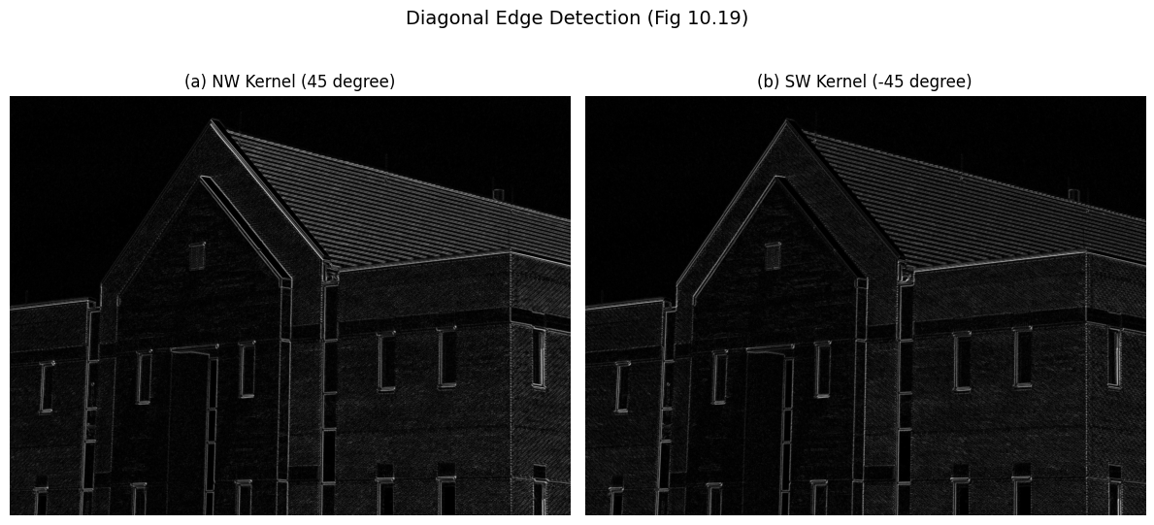

**Homework12: Implement Figure 10.20 by programming with Python**

**Python Code:**

**import** numpy as np

**import** matplotlib.pyplot as plt

**import** os

**from** scipy **import** ndimage

**from** PIL **import** Image

**def** apply_average_filter(img_arr, kernel_size**=**5):

    img_float **=** img_arr.astype(float)

**return** ndimage.uniform_filter(img_float, size**=**kernel_size)

**def** compute_sobel_magnitude(img_arr):

    img_float **=** img_arr.astype(float) **/** 255.0

    kx **=** np.array([[**-**1, 0, 1],

                   [**-**2, 0, 2],

                   [**-**1, 0, 1]], dtype**=**float)

    ky **=** np.array([[**-**1, **-**2, **-**1],

                   [0, 0, 0],

                   [1, 2, 1]], dtype**=**float)

    gx **=** ndimage.convolve(img_float, kx)

    gy **=** ndimage.convolve(img_float, ky)

**return** np.abs(gx) **+** np.abs(gy)

**def** threshold_image(magnitude, percentage**=**0.33):

    max_val **=** np.max(magnitude)

    T **=** max_val **\*** percentage

    binary_edges **=** (magnitude >**=** T).astype(np.uint8) **\*** 255

**return** binary_edges

**def** process_thresholded_edges(image_path, output_dir):

    pil_img **=** Image.open(image_path).convert('L')

    img **=** np.array(pil_img)

    mag_original **=** compute_sobel_magnitude(img)

    edges_original **=** threshold_image(mag_original, percentage**=**0.33)

    img_smoothed **=** apply_average_filter(img, kernel_size**=**5)

    mag_smoothed **=** compute_sobel_magnitude(img_smoothed)

    edges_smoothed **=** threshold_image(mag_smoothed, percentage**=**0.33)

    fig, axes **=** plt.subplots(1, 2, figsize**=**(12, 6))

    fig.suptitle(f'Thresholded Gradient (Fig 10.20)', fontsize**=**14)

    axes[0].imshow(edges_original, cmap**=**'gray')

    axes[0].set_title('(a) Thresholded Gradient of Original Image')

    axes[0].axis('off')

    axes[1].imshow(edges_smoothed, cmap**=**'gray')

    axes[1].set_title('(b) Thresholded Gradient of Smoothed Image')

    axes[1].axis('off')

    plt.tight_layout()

    save_path **=** os.path.join(output_dir, "Fig1020_thresholded_edges.png")

    plt.savefig(save_path, bbox_inches**=**'tight')

    plt.close()

**if** __name__ **==** "__main__":

    input_dir **=** "original_image"

    output_dir **=** "output_image"

    os.makedirs(output_dir, exist_ok**=**True)

    filename **=** "Fig1016(a)(building_original).tif"

    path **=** os.path.join(input_dir, filename)

    process_thresholded_edges(path, output_dir)

**Processed Images：**

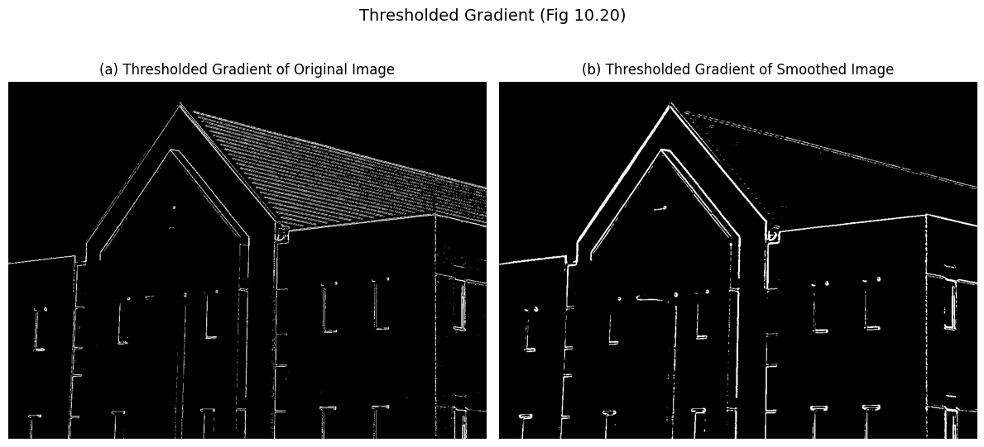

**Homework13: Implement Figure 10.22 by programming with Python**

**Python Code:**

**import** numpy as np

**import** matplotlib.pyplot as plt

**import** os

**from** scipy **import** ndimage

**from** PIL **import** Image

**def** compute_log_response(img_arr, sigma**=**4):

    """

    Compute Laplacian of Gaussian (LoG)

    """

    img_float **=** img_arr.astype(float)

    log_response **=** ndimage.gaussian_laplace(img_float, sigma**=**sigma, truncate**=**3.0)

**return** log_response

**def** find_zero_crossings(log_img, threshold**=**0):

    """

    Find zero crossings

    """

    rows, cols **=** log_img.shape

    edges **=** np.zeros_like(log_img, dtype**=**np.uint8)

    curr_h **=** log_img[:, :**-**1]

    right_h **=** log_img[:, 1:]

    sign_diff_h **=** (curr_h **\*** right_h) < 0

    curr_v **=** log_img[:**-**1, :]

    down_v **=** log_img[1:, :]

    sign_diff_v **=** (curr_v **\*** down_v) < 0

**if** threshold > 0:

        mag_check_h **=** np.abs(curr_h **-** right_h) > threshold

        mag_check_v **=** np.abs(curr_v **-** down_v) > threshold

        edges[:, :**-**1][sign_diff_h & mag_check_h] **=** 255

        edges[:**-**1, :][sign_diff_v & mag_check_v] **=** 255

**else**:

        edges[:, :**-**1][sign_diff_h] **=** 255

        edges[:**-**1, :][sign_diff_v] **=** 255

**return** edges

**def** process_marr_hildreth_final(image_path, output_dir):

    pil_img **=** Image.open(image_path).convert('L')

    img **=** np.array(pil_img)

    noise **=** np.random.normal(0, 1.0, img.shape)

    img_noisy **=** img.astype(float) **+** noise

    log_response **=** compute_log_response(img_noisy, sigma**=**4)

    max_log **=** np.max(np.abs(log_response))

**if** max_log **==** 0: max_log **=** 1

    display_log **=** ((log_response **/** max_log) **\*** 127.5 **+** 127.5).astype(np.uint8)

    edges_zero **=** find_zero_crossings(log_response, threshold**=**0)

    thresh_val **=** 0.04 **\*** max_log

    edges_thresh **=** find_zero_crossings(log_response, threshold**=**thresh_val)

    plt.rcParams.update({'font.size': 10})

    fig, axes **=** plt.subplots(2, 2, figsize**=**(10, 12))

    axes[0, 0].imshow(img, cmap**=**'gray')

    axes[0, 0].set_title('(a) Original Image')

    axes[0, 0].axis('off')

    axes[0, 1].imshow(display_log, cmap**=**'gray')

    axes[0, 1].set_title('(b) LoG (sigma=4, n=25)')

    axes[0, 1].axis('off')

    axes[1, 0].imshow(edges_zero, cmap**=**'gray')

    axes[1, 0].set_title('(c) Zero Crossing (Thresh=0)')

    axes[1, 0].axis('off')

    axes[1, 1].imshow(edges_thresh, cmap**=**'gray')

    axes[1, 1].set_title('(d) Zero Crossing (Thresh=4% Max)')

    axes[1, 1].axis('off')

    plt.tight_layout()

    save_path **=** os.path.join(output_dir, "Fig1022_Marr_Hildreth_Final.png")

    plt.savefig(save_path, bbox_inches**=**'tight')

    plt.close()

**if** __name__ **==** "__main__":

    input_dir **=** "original_image"

    output_dir **=** "output_image"

    os.makedirs(output_dir, exist_ok**=**True)

    filename **=** "Fig1016(a)(building_original).tif"

    path **=** os.path.join(input_dir, filename)

process_marr_hildreth_final(path, output_dir)

**Processed Images：**

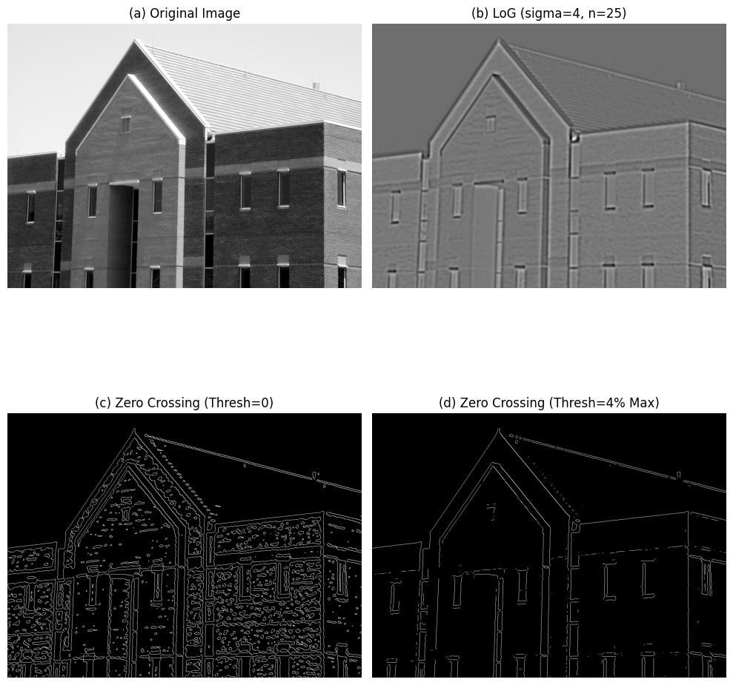

**Homework14: Implement Figure 10.25 by programming with Python**

**Python Code:**

**import** numpy as np

**import** matplotlib.pyplot as plt

**import** os

**from** scipy **import** ndimage

**from** PIL **import** Image

**def** gaussian_kernel(size, sigma**=**1):

    size **=** int(size) **//** 2

    x, y **=** np.mgrid[**-**size:size **+** 1, **-**size:size **+** 1]

    normal **=** 1 **/** (2.0 **\*** np.pi **\*** sigma **\*\*** 2)

    g **=** np.exp(**-**((x **\*\*** 2 **+** y **\*\*** 2) **/** (2.0 **\*** sigma **\*\*** 2))) **\*** normal

**return** g

**def** apply_average_filter(img_arr, kernel_size**=**5):

    img_float **=** img_arr.astype(float)

**return** ndimage.uniform_filter(img_float, size**=**kernel_size)

**def** get_image_b(img):

    img_smoothed **=** apply_average_filter(img, kernel_size**=**5)

    img_float **=** img_smoothed.astype(float) **/** 255.0

    kx **=** np.array([[**-**1, 0, 1], [**-**2, 0, 2], [**-**1, 0, 1]], dtype**=**float)

    ky **=** np.array([[**-**1, **-**2, **-**1], [0, 0, 0], [1, 2, 1]], dtype**=**float)

    gx **=** ndimage.convolve(img_float, kx)

    gy **=** ndimage.convolve(img_float, ky)

    magnitude **=** np.abs(gx) **+** np.abs(gy)

    max_val **=** np.max(magnitude)

    threshold **=** 0.33 **\*** max_val

    edges **=** (magnitude >**=** threshold).astype(np.uint8) **\*** 255

**return** edges

**def** get_image_c(img):

    img_float **=** img.astype(float)

    log_resp **=** ndimage.gaussian_laplace(img_float, sigma**=**4, truncate**=**3.0)

    max_log **=** np.max(np.abs(log_resp))

    threshold **=** 0.04 **\*** max_log

    edges **=** np.zeros_like(img, dtype**=**np.uint8)

    curr_h **=** log_resp[:, :**-**1]

    right_h **=** log_resp[:, 1:]

    sign_diff_h **=** (curr_h **\*** right_h) < 0

    mag_check_h **=** np.abs(curr_h **-** right_h) > threshold

    edges[:, :**-**1][sign_diff_h & mag_check_h] **=** 255

    curr_v **=** log_resp[:**-**1, :]

    down_v **=** log_resp[1:, :]

    sign_diff_v **=** (curr_v **\*** down_v) < 0

    mag_check_v **=** np.abs(curr_v **-** down_v) > threshold

    edges[:**-**1, :][sign_diff_v & mag_check_v] **=** 255

**return** edges

**def** sobel_filters_manual(img):

    Kx **=** np.array([[**-**1, 0, 1], [**-**2, 0, 2], [**-**1, 0, 1]], dtype**=**float)

    Ky **=** np.array([[**-**1, **-**2, **-**1], [0, 0, 0], [1, 2, 1]], dtype**=**float)

    Ix **=** ndimage.convolve(img, Kx)

    Iy **=** ndimage.convolve(img, Ky)

    G **=** np.hypot(Ix, Iy)

    G **=** G **/** G.max() **\*** 255

    theta **=** np.arctan2(Iy, Ix)

**return** G, theta

**def** non_max_suppression_manual(img, D):

    M, N **=** img.shape

    Z **=** np.zeros((M, N), dtype**=**np.float32)

    angle **=** D **\*** 180. **/** np.pi

    angle[angle < 0] **+=** 180

**for** i **in** range(1, M **-** 1):

**for** j **in** range(1, N **-** 1):

**try**:

                q **=** 255

                r **=** 255

**if** (0 <**=** angle[i, j] < 22.5) **or** (157.5 <**=** angle[i, j] <**=** 180):

                    q **=** img[i, j **+** 1]

                    r **=** img[i, j **-** 1]

**elif** (22.5 <**=** angle[i, j] < 67.5):

                    q **=** img[i **+** 1, j **-** 1]

                    r **=** img[i **-** 1, j **+** 1]

**elif** (67.5 <**=** angle[i, j] < 112.5):

                    q **=** img[i **+** 1, j]

                    r **=** img[i **-** 1, j]

**elif** (112.5 <**=** angle[i, j] < 157.5):

                    q **=** img[i **-** 1, j **-** 1]

                    r **=** img[i **+** 1, j **+** 1]

**if** (img[i, j] >**=** q) **and** (img[i, j] >**=** r):

                    Z[i, j] **=** img[i, j]

**else**:

                    Z[i, j] **=** 0

**except** IndexError:

**pass**

**return** Z

**def** hysteresis_manual(img, weak, strong**=**255):

    M, N **=** img.shape

    strong_rows, strong_cols **=** np.where(img **==** strong)

    stack **=** list(zip(strong_rows, strong_cols))

**while** stack:

        i, j **=** stack.pop()

**for** di **in** [**-**1, 0, 1]:

**for** dj **in** [**-**1, 0, 1]:

**if** di **==** 0 **and** dj **==** 0: **continue**

                ni, nj **=** i **+** di, j **+** dj

**if** 0 <**=** ni < M **and** 0 <**=** nj < N:

**if** img[ni, nj] **==** weak:

                        img[ni, nj] **=** strong

                        stack.append((ni, nj))

**for** i **in** range(M):

**for** j **in** range(N):

**if** img[i, j] **==** weak:

                img[i, j] **=** 0

**return** img

**def** get_image_d_manual_canny(img):

    img_float **=** img.astype(float)

    kernel **=** gaussian_kernel(size**=**25, sigma**=**4)

    img_smoothed **=** ndimage.convolve(img_float, kernel)

    grad_mag, grad_dir **=** sobel_filters_manual(img_smoothed)

    img_nms **=** non_max_suppression_manual(grad_mag, grad_dir)

    max_val **=** img_nms.max()

    lowThreshold **=** max_val **\*** 0.04

    highThreshold **=** max_val **\*** 0.10

    res **=** np.zeros_like(img_nms, dtype**=**np.int32)

    weak_val **=** np.int32(50)

    strong_val **=** np.int32(255)

    strong_i, strong_j **=** np.where(img_nms >**=** highThreshold)

    weak_i, weak_j **=** np.where((img_nms <**=** highThreshold) & (img_nms >**=** lowThreshold))

    res[strong_i, strong_j] **=** strong_val

    res[weak_i, weak_j] **=** weak_val

    img_final **=** hysteresis_manual(res, weak_val, strong_val)

**return** img_final

**def** process_comparison(image_path, output_dir):

    pil_img **=** Image.open(image_path).convert('L')

    img **=** np.array(pil_img)

    img_b **=** get_image_b(img)

    img_c **=** get_image_c(img)

    img_d **=** get_image_d_manual_canny(img)

    fig, axes **=** plt.subplots(2, 2, figsize**=**(12, 10))

    axes[0, 0].imshow(img, cmap**=**'gray')

    axes[0, 0].set_title('(a) Original Image')

    axes[0, 0].axis('off')

    axes[0, 1].imshow(img_b, cmap**=**'gray')

    axes[0, 1].set_title('(b) Thresholded Gradient (Smoothed)')

    axes[0, 1].axis('off')

    axes[1, 0].imshow(img_c, cmap**=**'gray')

    axes[1, 0].set_title('(c) Marr-Hildreth (LoG)')

    axes[1, 0].axis('off')

    axes[1, 1].imshow(img_d, cmap**=**'gray')

    axes[1, 1].set_title('(d) Canny Algorithm (Manual)')

    axes[1, 1].axis('off')

    plt.tight_layout()

    save_path **=** os.path.join(output_dir, "Fig1025_Full_Comparison_Manual.png")

    plt.savefig(save_path, bbox_inches**=**'tight')

    plt.close()

**if** __name__ **==** "__main__":

    input_dir **=** "original_image"

    output_dir **=** "output_image"

    os.makedirs(output_dir, exist_ok**=**True)

    filename **=** "Fig1016(a)(building_original).tif"

    path **=** os.path.join(input_dir, filename)

    process_comparison(path, output_dir)

**Processed Images：**

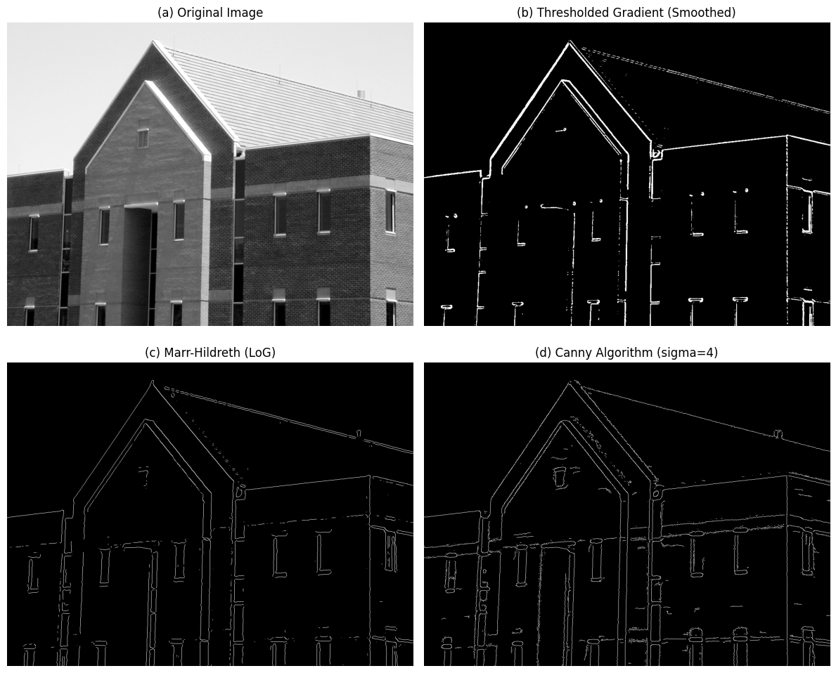

**Homework15: Implement Figure 10.26 by programming with Python**

**Python Code:**

**import** numpy as np

**import** matplotlib.pyplot as plt

**import** os

**from** scipy **import** ndimage

**from** PIL **import** Image

**def** gaussian_kernel(size, sigma**=**1):

    size **=** int(size) **//** 2

    x, y **=** np.mgrid[**-**size:size **+** 1, **-**size:size **+** 1]

    normal **=** 1 **/** (2.0 **\*** np.pi **\*** sigma **\*\*** 2)

    g **=** np.exp(**-**((x **\*\*** 2 **+** y **\*\*** 2) **/** (2.0 **\*** sigma **\*\*** 2))) **\*** normal

**return** g

**def** sobel_filters_manual(img):

    Kx **=** np.array([[**-**1, 0, 1], [**-**2, 0, 2], [**-**1, 0, 1]], dtype**=**float)

    Ky **=** np.array([[**-**1, **-**2, **-**1], [0, 0, 0], [1, 2, 1]], dtype**=**float)

    Ix **=** ndimage.convolve(img, Kx)

    Iy **=** ndimage.convolve(img, Ky)

    G **=** np.hypot(Ix, Iy)

    theta **=** np.arctan2(Iy, Ix)

**return** G, theta

**def** non_max_suppression_manual(img, D):

    M, N **=** img.shape

    Z **=** np.zeros((M, N), dtype**=**np.float32)

    angle **=** D **\*** 180. **/** np.pi

    angle[angle < 0] **+=** 180

**for** i **in** range(1, M **-** 1):

**for** j **in** range(1, N **-** 1):

**try**:

                q **=** 255

                r **=** 255

**if** (0 <**=** angle[i, j] < 22.5) **or** (157.5 <**=** angle[i, j] <**=** 180):

                    q **=** img[i, j **+** 1]

                    r **=** img[i, j **-** 1]

**elif** (22.5 <**=** angle[i, j] < 67.5):

                    q **=** img[i **+** 1, j **-** 1]

                    r **=** img[i **-** 1, j **+** 1]

**elif** (67.5 <**=** angle[i, j] < 112.5):

                    q **=** img[i **+** 1, j]

                    r **=** img[i **-** 1, j]

**elif** (112.5 <**=** angle[i, j] < 157.5):

                    q **=** img[i **-** 1, j **-** 1]

                    r **=** img[i **+** 1, j **+** 1]

**if** (img[i, j] >**=** q) **and** (img[i, j] >**=** r):

                    Z[i, j] **=** img[i, j]

**else**:

                    Z[i, j] **=** 0

**except** IndexError:

**pass**

**return** Z

**def** hysteresis_manual(img, weak, strong**=**255):

    M, N **=** img.shape

    strong_rows, strong_cols **=** np.where(img **==** strong)

    stack **=** list(zip(strong_rows, strong_cols))

**while** stack:

        i, j **=** stack.pop()

**for** di **in** [**-**1, 0, 1]:

**for** dj **in** [**-**1, 0, 1]:

**if** di **==** 0 **and** dj **==** 0: **continue**

                ni, nj **=** i **+** di, j **+** dj

**if** 0 <**=** ni < M **and** 0 <**=** nj < N:

**if** img[ni, nj] **==** weak:

                        img[ni, nj] **=** strong

                        stack.append((ni, nj))

**for** i **in** range(M):

**for** j **in** range(N):

**if** img[i, j] **==** weak:

                img[i, j] **=** 0

**return** img

**def** get_image_b_thresholded_gradient(img_norm):

    img_smoothed **=** ndimage.uniform_filter(img_norm, size**=**5)

    Kx **=** np.array([[**-**1, 0, 1], [**-**2, 0, 2], [**-**1, 0, 1]], dtype**=**float)

    Ky **=** np.array([[**-**1, **-**2, **-**1], [0, 0, 0], [1, 2, 1]], dtype**=**float)

    gx **=** ndimage.convolve(img_smoothed, Kx)

    gy **=** ndimage.convolve(img_smoothed, Ky)

    magnitude **=** np.hypot(gx, gy)

    thresh_val **=** 0.15 **\*** np.max(magnitude)

    edges **=** (magnitude >**=** thresh_val).astype(np.uint8) **\*** 255

**return** edges

**def** get_image_c_marr_hildreth(img_norm):

    log_resp **=** ndimage.gaussian_laplace(img_norm, sigma**=**3, truncate**=**3.0)

    threshold **=** 0.002

    edges **=** np.zeros_like(img_norm, dtype**=**np.uint8)

    curr_h **=** log_resp[:, :**-**1]

    right_h **=** log_resp[:, 1:]

    sign_diff_h **=** (curr_h **\*** right_h) < 0

    mag_check_h **=** np.abs(curr_h **-** right_h) > threshold

    edges[:, :**-**1][sign_diff_h & mag_check_h] **=** 255

    curr_v **=** log_resp[:**-**1, :]

    down_v **=** log_resp[1:, :]

    sign_diff_v **=** (curr_v **\*** down_v) < 0

    mag_check_v **=** np.abs(curr_v **-** down_v) > threshold

    edges[:**-**1, :][sign_diff_v & mag_check_v] **=** 255

**return** edges

**def** get_image_d_manual_canny(img_norm):

    kernel **=** gaussian_kernel(size**=**13, sigma**=**2)

    img_smoothed **=** ndimage.convolve(img_norm, kernel)

    grad_mag, grad_dir **=** sobel_filters_manual(img_smoothed)

    grad_mag_norm **=** grad_mag **/** np.max(grad_mag) **if** np.max(grad_mag) > 0 **else** grad_mag

    img_nms **=** non_max_suppression_manual(grad_mag_norm, grad_dir)

    t_low **=** 0.05

    t_high **=** 0.15

    weak_val **=** np.int32(50)

    strong_val **=** np.int32(255)

    res **=** np.zeros_like(img_nms, dtype**=**np.int32)

    strong_i, strong_j **=** np.where(img_nms >**=** t_high)

    weak_i, weak_j **=** np.where((img_nms <**=** t_high) & (img_nms >**=** t_low))

    res[strong_i, strong_j] **=** strong_val

    res[weak_i, weak_j] **=** weak_val

    img_final **=** hysteresis_manual(res, weak_val, strong_val)

**return** img_final

**def** process_head_ct(image_path, output_dir):

    pil_img **=** Image.open(image_path).convert('L')

    img_norm **=** np.array(pil_img).astype(float) **/** 255.0

    img_b **=** get_image_b_thresholded_gradient(img_norm)

    img_c **=** get_image_c_marr_hildreth(img_norm)

    img_d **=** get_image_d_manual_canny(img_norm)

    fig, axes **=** plt.subplots(2, 2, figsize**=**(10, 10))

    # fig.suptitle('Edge Detection on Head CT (Fig 10.26)', fontsize=14)

    axes[0, 0].imshow(img_norm, cmap**=**'gray')

    axes[0, 0].set_title('(a) Original Image (Head CT)')

    axes[0, 0].axis('off')

    axes[0, 1].imshow(img_b, cmap**=**'gray')

    axes[0, 1].set_title('(b) Thresholded Gradient (15% Max)')

    axes[0, 1].axis('off')

    axes[1, 0].imshow(img_c, cmap**=**'gray')

    axes[1, 0].set_title('(c) Marr-Hildreth (LoG)')

    axes[1, 0].axis('off')

    axes[1, 1].imshow(img_d, cmap**=**'gray')

    axes[1, 1].set_title('(d) Canny Algorithm (Manual)')

    axes[1, 1].axis('off')

    plt.tight_layout()

    save_path **=** os.path.join(output_dir, "Fig1026_HeadCT_EdgeDetection.png")

    plt.savefig(save_path, bbox_inches**=**'tight')

    plt.close()

**if** __name__ **==** "__main__":

    input_dir **=** "original_image"

    output_dir **=** "output_image"

    os.makedirs(output_dir, exist_ok**=**True)

    filename **=** "Fig1026(a)(headCT-Vandy).tif"

    path **=** os.path.join(input_dir, filename)

process_head_ct(path, output_dir)

**Processed Images：**

